**TPICAP Provisioning Guide for RHEL7.x VM using PXE-Less via Red Hat Satellite**

**CONTENTS**

Table of Contents

1.0 Document Control 3

1.1 Version History 3

1.2 Document Review 3

1.3 Document References 3

1.4 Distribution List 3

2.0 INTRODUCTION 4

2.1 Overview 4

2.2 Applicability 4

2.3 Document Lifecycle 4

3.0 General Requirements 5

List of Requirements 5

4.0 PROVISIONING THE SERVER 5

4.1 Accessing the Satellite GUI 5

4.2 Creating the Host 6

4.3 The Host Tab 7

4.4 The Ansible Roles Tab 9

4.5 The Operating System Tab 10

4.6 The Interface Tab 11

4.7 The Puppet Classes, Parameters and Additional Information Tab 12

4.8 Saving and getting ready to build 12

4.9 Downloading the Boot ISO 13

4.10 Boot the Downloaded Image 13

4.11 The Ansible Job 14

# 1.0 Document Control

## 1.1 Version History

|  |  |  |  |
| --- | --- | --- | --- |
| **Version/Status** | **Date Issued** | **Document location** | **Comments** |
| 1.0 | July 1 2022 |  | 1st Draft |
| 2.0 | October 23 2022 |  | Modified for VM autobuild option |

## 1.2 Document Review

|  |  |  |  |
| --- | --- | --- | --- |
| **Version** | **Date Reviewed** | **Department/Function** | **Reviewed / Approved By** |
|  |  |  |  |
|  |  |  |  |
|  |  |  |  |

## 1.3 Document References

|  |  |  |
| --- | --- | --- |
| **Reference No.** | **Document** | **Version** |
|  |  |  |
|  |  |  |

## 1.4 Distribution List

|  |  |
| --- | --- |
| **Name** | **Title/Responsibility** |
|  |  |
|  |  |
|  |  |
|  |  |
|  |  |
|  |  |
|  |  |

# 2.0 INTRODUCTION

A standard way for TPICAP to build servers whether it’s a VM or a Physical Device

## 2.1 Overview

This document provides brief procedure on how to provision/build servers using Red Hat Satellite along with Ansible Integration. This includes post installation tasks that were agreed by the team to standardize builds across regions. It also includes Hardening Tasks which were actioned from the vulnerability report provided by Security Team.

## 2.2 Applicability

This applies to Global Unix/Linux team member work instruction.

## 2.3 Document Lifecycle

This guide MUST be reviewed no less than once per year for technical accuracy and business validity.

# 3.0 General Requirements

## List of Requirements

Whoever use this document MUST be part of Global Unix/Linux Admin with correct access permission to the server.

Before proceeding, we must have the following:

* Access to management(iLO for HPE/CIMC for Cisco/Admin Account for VMWare)
* Network Information(IP/Gateway/Netmask/MAC Address)
* DNS Entry(FQDN for Ansible to work)
* Firewall/Contract Rules Allowed. Click [HERE](https://teams.microsoft.com/l/entity/com.microsoft.teamspace.tab.wiki/tab::9f0ae5a3-7edf-43e1-9f7e-589c638c427f?context=%7B%22subEntityId%22%3A%22%7B%5C%22pageId%5C%22%3A2%2C%5C%22sectionId%5C%22%3A13%2C%5C%22origin%5C%22%3A2%7D%22%2C%22channelId%22%3A%2219%3A01c1bc739d1844c3a47e715cfbd6ec6a%40thread.skype%22%7D&tenantId=7bc8ad67-ee7f-43cb-8a42-1ada7dcc636e) to see the procedure on how to request this via OneStore
* Web Browser(IE/Chrome/Firefox)
* Admin access to Satellite Page and/or SSH Access to ldnpinfuxm03.eur.ad.tullib.com(satellite server)
* Satellite vCenter connectivity must be in placed

# 4.0 PROVISIONING THE SERVER

## 4.1 Accessing the Satellite GUI

Open your favorite browser and go to the Satellite Page <https://ldnpinfuxm03.eur.ad.tullib.com/>

Login using your CORP -a Admin Account. If your account is CORP\catienza-a, just type in catienza-a on the Username Input Box.

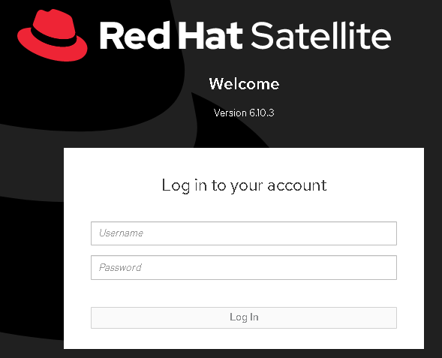

## 4.2 Creating the Host

From the Dashboard, Click on Hosts 🡪 Create Host. You will be redirected to the Create Host Page.

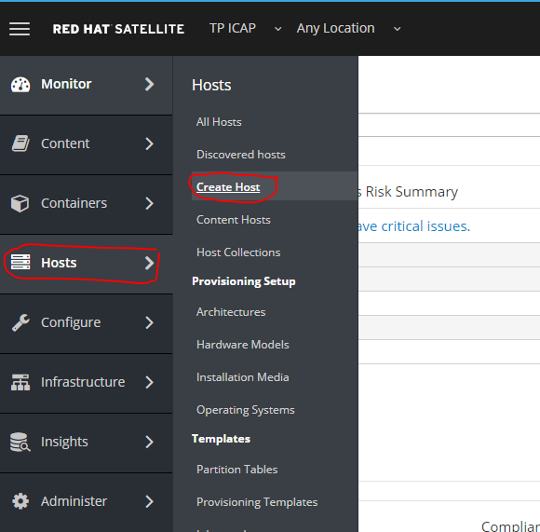

At first, you will be presented with a bunch of drop downs.

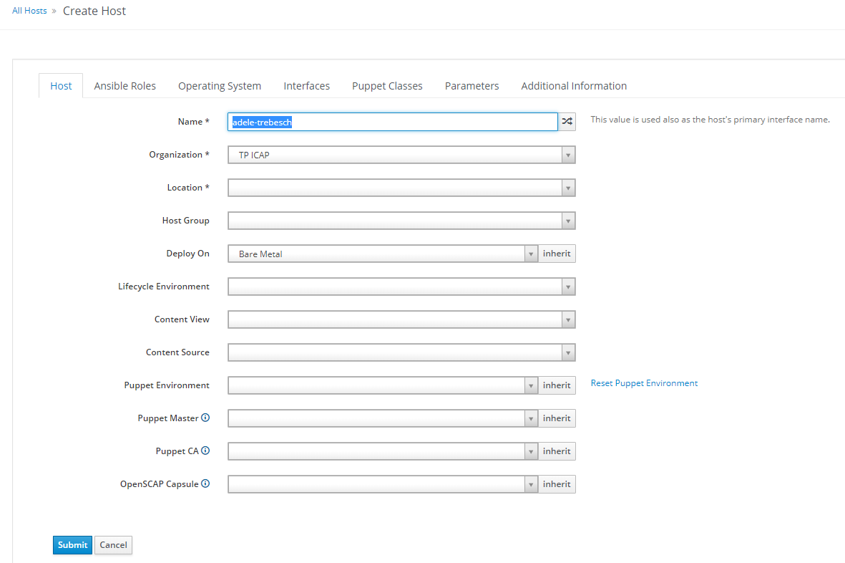

## 4.3 The Host Tab

Fill in the blanks as explained below:

Name The preferred hostname for your server

Organization This is defaulted to TP ICAP

Location The exact datacentre for your server

Host Group Choose whether it’s HG-RHEL7 PROD/DEV ARK/LD5 Template

Deploy On This will automatically auto filled when you select Template

Compute profile Auto filled based on the template selected

Lifecycle Environment Choose whether it’s a production or development

Content View A set of repositories. The default is cv-RHEL7Server-with-EPEL7

Content Source Choose ldnpinfuxm03.eur.ad.tullib.com(satellite server)

Puppet Environment leave blank, we’ll use ansible for this

Puppet Master leave blank, we’ll use ansible for this

Puppet CA leave blank, we’ll use ansible for this

OpenSCAP Capsule leave blank, we use Qualys for this

Here is a filled in sample.

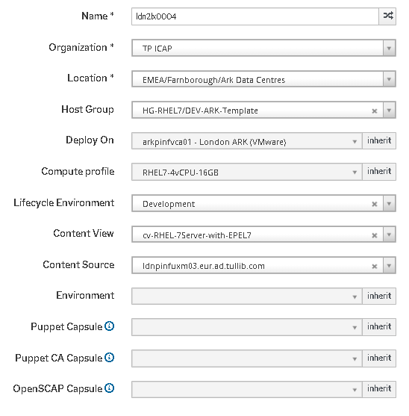

## 4.4 The Ansible Roles Tab

We have 6 Playbook to add by default when provisioning.

* **rhel76-hardening** – a set of tasks to remediate/patch/remove/ vulnerabilities found. The list of all vulnerabilities that have been worked on are in [**HERE**](https://teams.microsoft.com/l/file/C0217379-4774-4F08-B5A0-B465B4D6B0E3?tenantId=7bc8ad67-ee7f-43cb-8a42-1ada7dcc636e&fileType=xlsx&objectUrl=https%3A%2F%2Ftpicap365.sharepoint.com%2Fteams%2FTPICAPGlobalUnixAdministrators%2FShared%20Documents%2FGolden%20Builds%2FRHEL7%20Hardening%20Patch%20List.xlsx&baseUrl=https%3A%2F%2Ftpicap365.sharepoint.com%2Fteams%2FTPICAPGlobalUnixAdministrators&serviceName=teams&threadId=19:60104ba2625e4e79a279296e5e3d800c@thread.skype&groupId=c28a0d2d-3551-4158-82aa-8529deddc277).
* **common-tools-realm** – adds a custom repo and install some common packages including realm configuration to connect into AD that are used by the team
* **security-tools** – adds the Qualys User along with sudo configuration for vulnerability scanning, by Security Team
* appdynamics-machine-agent
* cmdb-file-update – To add the newly build server into CMDB
* motd-update – TPICAP banner

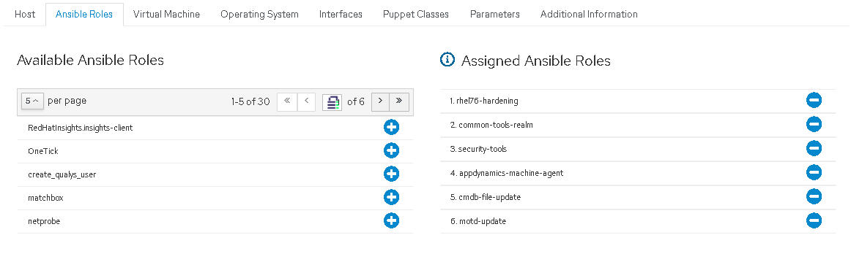

## 4.5 Virtual Machine

This tab will be populated based on the vCenter Location, you may modify according to the CPU, number of Cores and memory. Including it Cluster location, Resources and VM folder. You need to specify the Data store you wanted to use, refer to the default primary disk size for vg00.

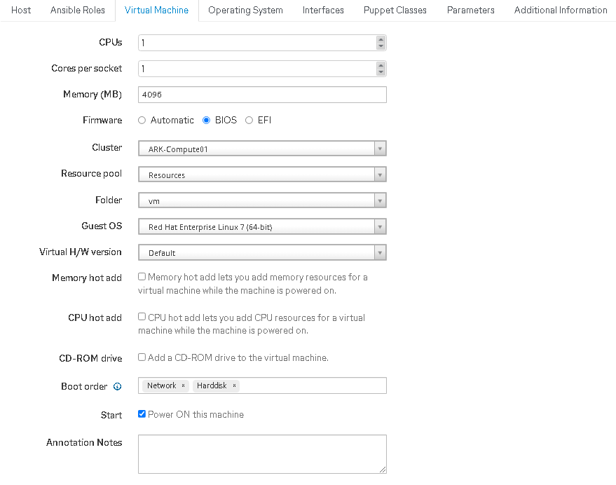

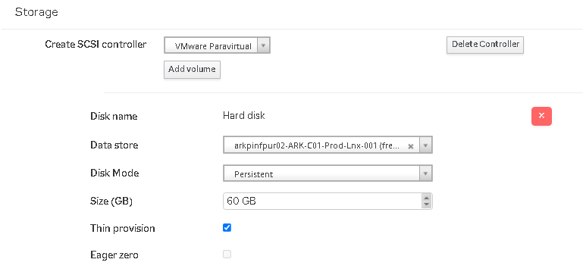

## Note: For secondary disk, click on Add Controller, select Data Store, make sure it has enough space to accommodate additional space.

## aDDING SECONDARY disk

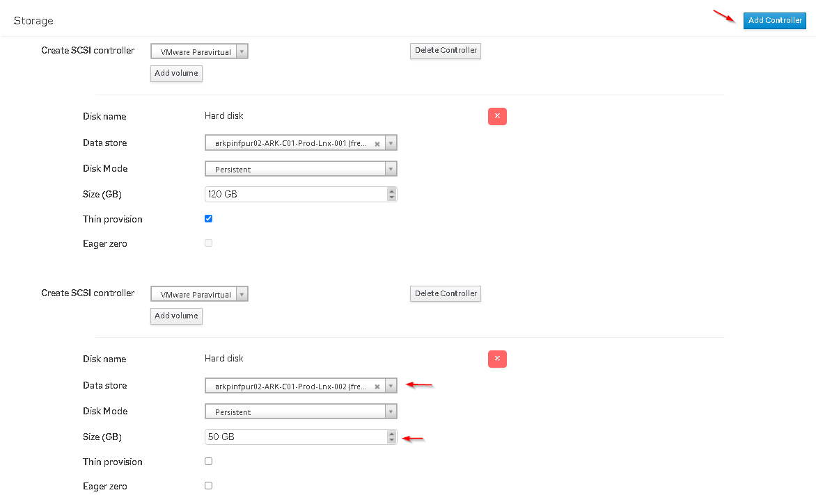

## 4.6 The Operating System Tab

This tab will be populated along when you choose your preferred **HostGroup** under the Host Tab

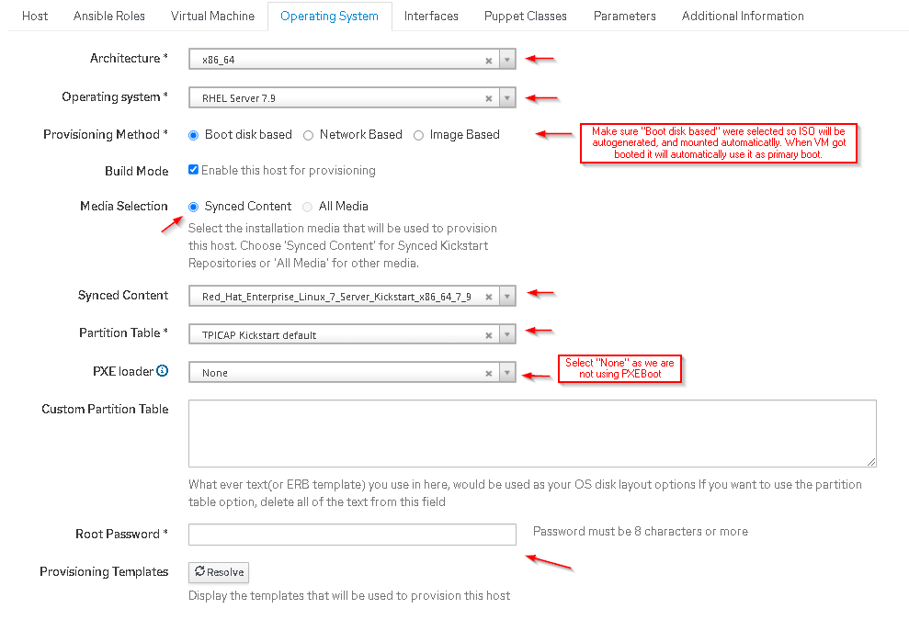

Default Root password will be **“s5tbu1ld**”

## 4.7 The Interface Tab

This tab lets you configure the network configuration of the server. Click Edit on the Interface and fill in the required fields as shown below

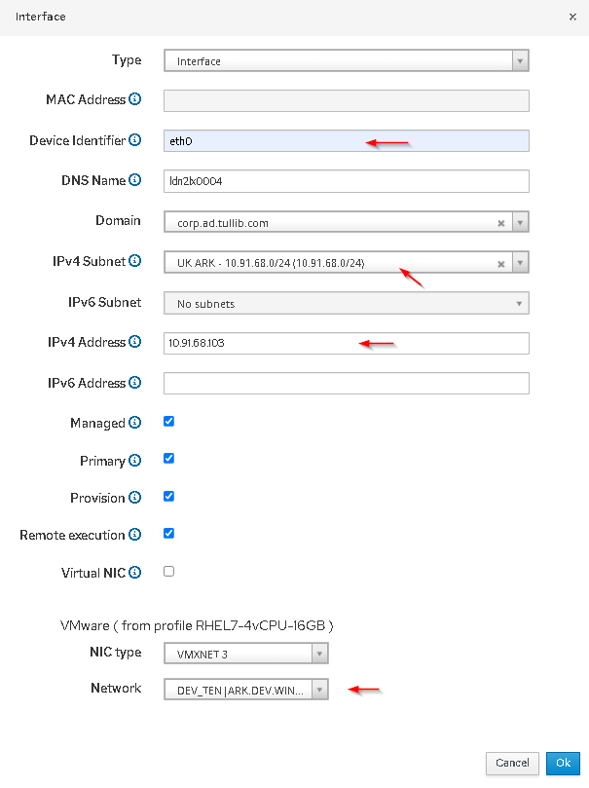

**Note**: MAC address **no longer** required to put as it will automatically populated, including DNS Names, and Domain. For VLAN/EPG you may select the drop down under Network and choose accordingly. Once you selected the VLAN/EPG, the IPv4 Subnet will list all available subnets. Pay attention to the IP Address, you should put the IP address according to the subnet you selected. Click OK to proceed.

## 4.8 The Puppet classes, parameters and additiONAL INFORMATION TAB.

We use Ansible for integration hence, we’ll skip the puppet tab.

The Parameters Tab has some preconfigured fields so no need to add/edit unless required. 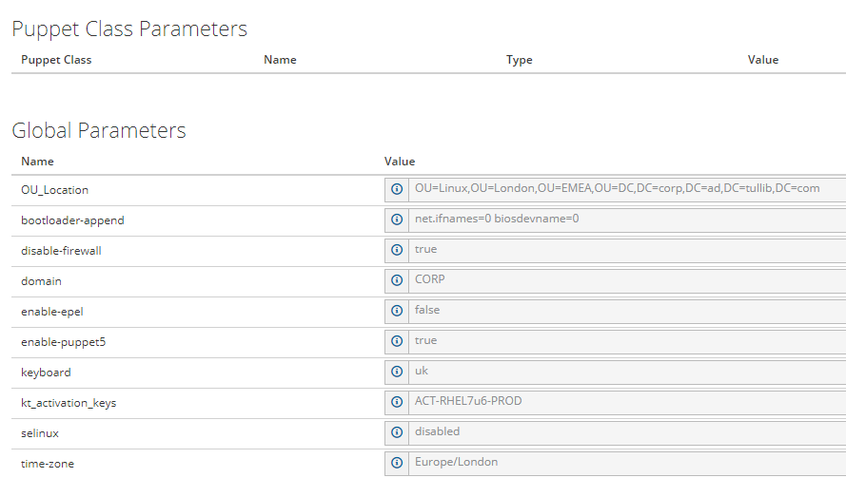The Additional Information Tab lets you to put Comment.  
  
Once everything has been filled up, click on save and you will be back on the Hosts Properties Page.

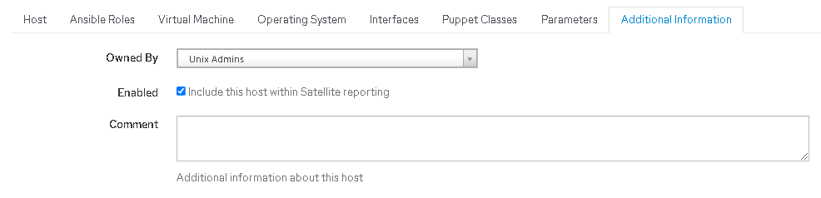

## 4.9 PROCESSING the BUILD PROGRESS



Note: Once Click Submit, you will find similar progress messages below.

## 

If all got completed server will automatically Power On and you may click on Console to see the installation progress.

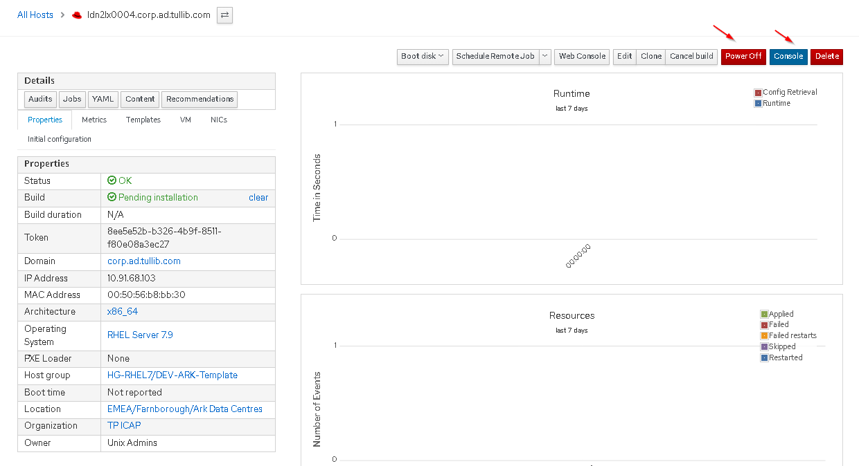

## 4.10 installation progress

Click on Console, then “Launch Console” to see the installation progress.

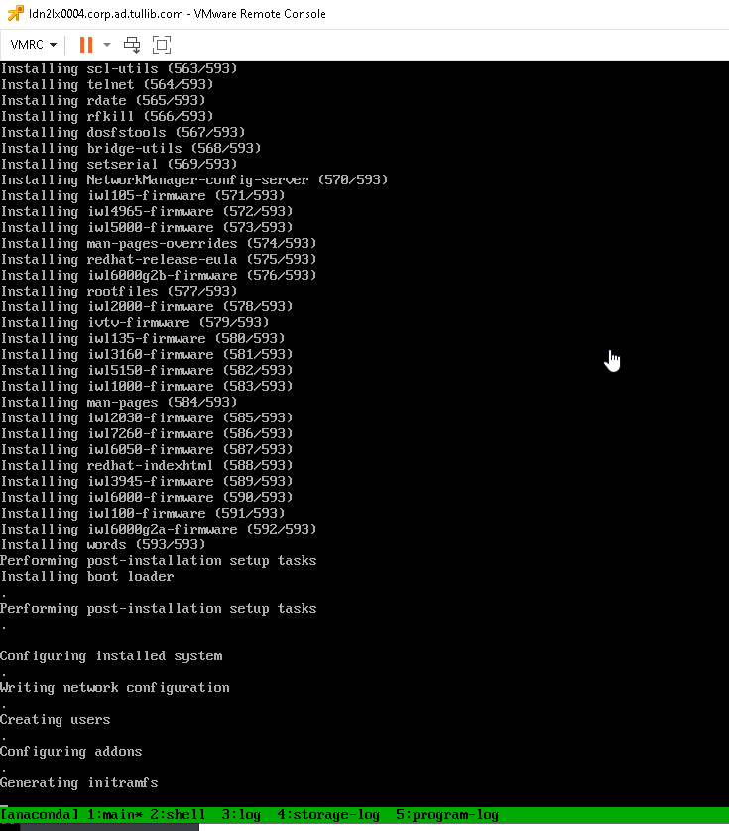

Once installation got completed, it will prompt to ejecting the ISO image and boot from disk.

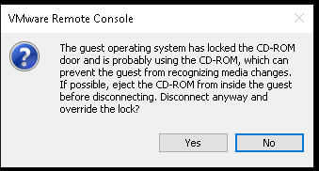

Click “Yes” to eject the ISO image.

Once you find similar screen below, server got built. Proceed running the Ansible Job.

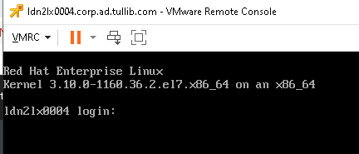

## 4.11 Run the ansible ROLES

Go back to the Satellite page and Click the drop down “Schedule Remote Job” and select “Run Ansible roles”. You will find similar screen below once Ansible Roles got completed.

